计算机专业英语复习资料2016.6.6
- 写出以下缩略语对应的英文和中文全称（20*1.5’=30’，英文1分，中文0.5分）
- ALU：Arithmetic Logical Unit算术逻辑单元
- AI：Artificial Intelligence人工智能
- ANSI：American National Standards Institute美国国家标准学会
- API：Application Program Interface应用程序界面
- ASP：Active Server Page动态服务器网页
- BBS：Bulletin Board System电子布告栏
- B2B：Business to Business商业机构对商业机构的电子商务
- B2C：Business to Consumer商业机构对消费者的电子商务
- bps：bits per second每秒传送位数
- BIOS：Basic Input / Output System基本输入/输出系统
- CAD：Computer - Aided Design计算机辅助设计
- CASE：Computer Aided Software Engineering计算机辅助软件工程
- CAE(Computer-Aided Engineering)计算机辅助工程
- CAI：Computer Aided Instruction计算机辅助教学
- CAM：Computer Aided Manufacturing计算机辅助管理
- CAT：Computer Aided Test计算机辅助测试
- CCF：China Computer Federation中国计算机学会
- CFP：Call For Papers征文启事
- CGI：Common Gateway Interface公共网关接口
- CISC：Complex Instruction Set Computer 复杂指令集计算机
- COM：Component object model组件对象模型
- CPU：Central Processing Unit中央处理机
- CSS：Cascading Style Sheets层叠样式表
- DBA：DataBase Administrator数据库管理员
- DBMS(Database Management System)数据库管理系统
- DNS：Domain Name Server域名服务器
- DOS：Disk Operating System磁盘操作系统
- DSL：Digital Subscriber Line数字用户线路
- EDI：Electronic Data Interchange电子数据交换
- EI：Engineering Index工程索引
- ERP：Enterprise Resource Planning企业资源计划
- FAT：File Allocation Table文件分配表
- FCB：File Control Block文件控制块
- FCFS：First Come First Service先到先服务
- FIFO：First In First Out先进先出
- FTP：File Transfer Protocol文件传输协议
- GIS：Geographic Information System地理信息系统
- GPS：Global Position System全球定位系统
- GUI：Graphical User Interfaces图形用户界面
- HMI：Human Machine Interface人机界面
- HTML：Hypertext Markup Language超文本标记语言
- HTTP：Hyper Text Transport Protocol超文本传输协议
- IC：Integrated Circuit集成电路
- IDE：Integrated Development Environment集成开发环境
- IEEE：Institute of Electrical and Electronics Engineering电子电器工程师协会
- IIS：Internet Information Service因特网信息服务
- IP：Internet Protocol因特网协议
- ISA：Industry Standard Architecture工业标准结构，是 IBM PC/ XT总线标准
- ISO：International Standard Organization
- ISDN：Integrated Service Digital Network综合业务数字网
- ISP：Internet Service Provider网络服务提供者
- ISTP：Index to Scientific & Technical Proceedings科技会议录索引
- IT：Information Technology信息技术（不能填写意大利等）
- ITU：International Telecommunication Union国际电信联盟
- JPEG：Joint Photographic Experts Group联合图片专家组
- JDBC：Java DataBase Connectivity Java数据库连接
- JVM：Java Virtual Machine Java虚拟机
- LAN：Local Area Networks局域网
- MIDI：Musical Instrument Digital Interface音乐设备数字接口
- MIPS：Million Instructions Per Second每秒百万指令
- MIS：Management Information System管理信息系统
- MPEG：Moving Picture Experts Group运动图像专家组
- OA：Of f ice Automation办公自动化
- OCR：Optical Character Recognition光学字符识别
- ODBC：Open Database Connectivity开放式数据库互联
- OOP：Object Oriented Programming面向对象的程序设计
- OS：Operating System操作系统
- OSI：Open System Interconnection开放系统互连
- PC：Personal Computer个人电脑
- PCB：Process Control Block进程控制块
- PHP：Hypertext Preprocessor超级文本预处理语言
- RAID：Redundant Array Independent Disk冗余列阵磁盘机
- RAM：Random Access Memory随机存取存储器
- RDBMS：Relational Database Management System关系型数据库管理系统
- RFID：Radio Frequency Identification Devices无线射频识别
- RISC：Reduced Instruction Set Computer精简指令集计算机
- ROM：Read Only Memory只读存储器
- RUP：Rational Unified Process统一软件开发过程
- SCI：Science Citation Index科学引文索引
- SCSI：Small Computer System Interface小型计算机系统接口
- SDK：Software Development Kit软体开发套件
- SMTP：Simple Mail Transfer Protocol简单邮件传输协议
- SQA：Software Quality Assurance软件质量保证
- SQL：Structured Query Language结构化查询语言
- TCP/IP：Transmission Control Protocol / Internet Protocol传输控制/网络通讯协定
- UDP：User Datagram Protocol用户数据报协议
- UI：User Interface用户界面，用户接口
- UML：Unified Modeling Language统一建模语言
- UPS：Uninterruptible Power Supply不间断电源
- URL：Uniform Resource Locator统一资源定位器
- USB：Universal Serial Bus通用串行总线
- VLSI：Very Large Scale Integration超大规模集成电路
- VM：Virtual Machine虚拟机
- VPN：Virtual Private Network虚拟专用网络
- VR：Virtual Reality虚拟现实
- WAN：Wide Area Networks广域网
- WSN：Wireless Sensor Network无线传感网
- WWW：World Wide Web万维网
- WYSIWYG：What You See Is What You Get所见即所得
- XML：eXtensible Markup Language可扩展标记语言

- 把以下字符翻译成英文（5*1’=5’）
空格 | Space sign | # | Hash mark | * | Asterisk
% | Percent sign | / | Slash | - | Hyphen
( | Left parenthesis | < | Less than | = | Equals sign
> | Greater than | ? | Question mark | @ | At sign
\ | Backslash | _ | Underscore | { | Left curly brace

- 翻译CCF专业委员会名称（中译英）（5*1’=5’）
- Information System信息系统
- Sensor Network 传感器网络
- Big Data大数据
- Multimedia Technology 多媒体技术
- Multiple-Valued and Fuzzy Logic多值逻辑与模糊逻辑
- Service Computing 服务计算
- High Performance Computing 高性能计算
- Industrial Control Computer工业控制计算机
- Internet互联网
- Computer Security 计算机安全
- CAD and Graphics 计算机辅助设计与图形学
- Computer Engineering and Techniques 计算机工程与工艺
- Task Force on Computer Vision计算机视觉
- Computer Applications 计算机应用
- Education教育
- Financial Information Processing金融信息处理
- Distributed Computing and Processing分布式计算与处理（原来的开发系统）
- Database 数据库
- Severe Environment Computer 抗恶劣环境计算机
- Theoretical Computer Science理论计算机科学
- Petri Nets佩特里网
- Pervasive Computing 普适计算
- Artificial Intelligence & Pattern Recognition 人工智能与模式识别
- Human Computer Interaction人机交互
- Fault Tolerant Computing 容错计算
- Software Engineering 软件工程
- Computer Architecture 体系结构
- Network and Data Communications 网络与数据通信
- Embedded Systems嵌入式系统
- Systems Software系统软件
- Cooperative Computing 协同计算
- Information Security 信息保密
- Information Storage Technology信息存储技术
- Virtual Reality and Visualization Technology 虚拟现实与可视化技术
- Chinese Information Technology 中文信息技术

- 翻译课程全称（中译英）（10*1’=10’）
- 高等数学Advanced Mathematics
- 物联网工程（The Internet of Things Engineering）
- 线性代数Linear Algebra
- 概率统计Probability and Statistics
- 物联网导论(Introduction to Internet of Thing)
- 离散数学Discrete Mathematics
- C语言程序设计C Programming
- 数据结构Data Structure
- 模拟与数字电路设计(Analog and Digital Circuit Design)
- 计算机网络(Computer Networks)
- 组网技术综合实训(Comprehensive Training in Network Technology )
- 面向对象与C++程序设计(Object-Oriented and C++ Programming)
- 计算机通信原理(Computer Communication Principles)
- 数据库原理与设计(Database Theories and Design)
- 计算机组成及系统结构(Computer System Structure)
- 操作系统原理(Principles of Operating System)
- 嵌入式系统设计(Embedded System Design)
- 工程项目管理(Project Management)
- RFID与传感器技术(RFID and Sensor Technology)
- 电子测量(Electronic Measurement Technology)
- 传感器网络(Sensor Network)
- 软件工程概论(Introduction to Software Engineering)
- 毕业实习(Graduation Practice)
- 毕业设计(论文)(Graduation Project (Thesis))
- 计算机专业英语(English for Computer Science)
- 无线传感网技术(Wireless Sensor Network Technology)
- Java程序设计(Java Programming)
- 软件测试与质量保证(Software Quality Assurance and Testing)
- 高级数据库技术(Advanced Database Technology)
- 网络程序设计及应用(Network Programming and Application)
- 物联网计算技术(IoT Computing Technology)
- 智能感知与定位(Intelligent Perception and Location)

- 英译中（20’）

Chapter 0 Introduction
0.1 The Role of Algorithms
0.2 The History of Computing
0.3 The Science of Algorithms
0.4 Abstraction
0.5 An Outline of Our Study
0.6 Social Repercussions社会影响

Figure 0.2 The Euclidean algorithm
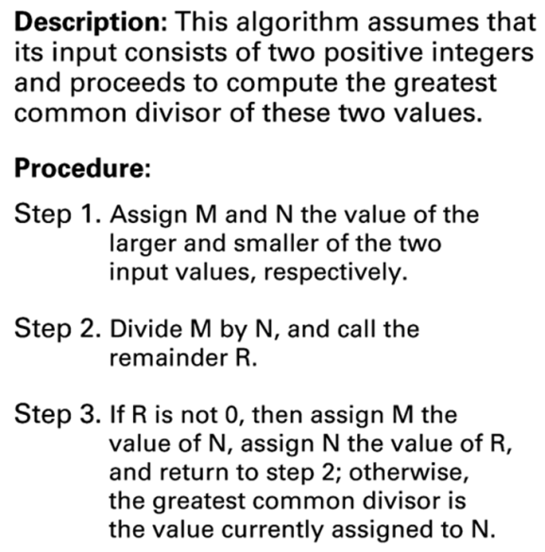
Outline of Our Study
Chapter 1: Data Storage
Chapter 2: Data Manipulation
Chapter 3: Operating Systems
Chapter 4: Networks and the Internet
Chapter 5: Algorithms
Chapter 6: Programming Languages
Chapter 7: Software Engineering
Chapter 8: Data Abstractions
Chapter 9: Database Systems
Chapter 10: Computer Graphics
Chapter 11: Artificial Intelligence
Chapter 12: Theory of Computation

Chapter 1 Data Storage
1.1 Bits and Their Storage
1.2 Main Memory
1.3 Mass Storage
1.4 Representing Information as Bit Patterns
1.5 The Binary System
1.6 Storing Integers
1.7 Storing Fractions
1.8 Data Compression
1.9 Communications Errors

Figure 1.17 An algorithm算法 for finding the binary representation表示 of a positive integer正整数
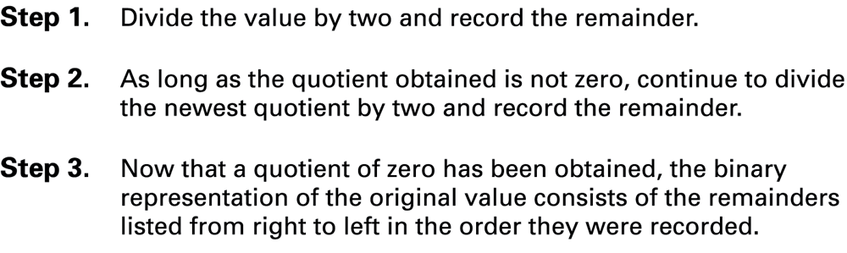
图1-17 求正整数二进制表示的算法
步骤1 将该值除以2，记下余数。
步骤2 只要所得的商不是0，就继续将最新的商除以2，并记下余数。
步骤3 商为0时，将余数按所记录的顺序从右到左依次排列，即得到原数的二进制表示。

Chapter 2 Data Manipulation
2.1 Computer Architecture
2.2 Machine Language
2.3 Program Execution
2.4 Arithmetic/Logic Instructions
2.5 Communicating with Other Devices
2.6 Other Architectures

Figure 2.2 Adding values stored in memory主存储器中的值相加
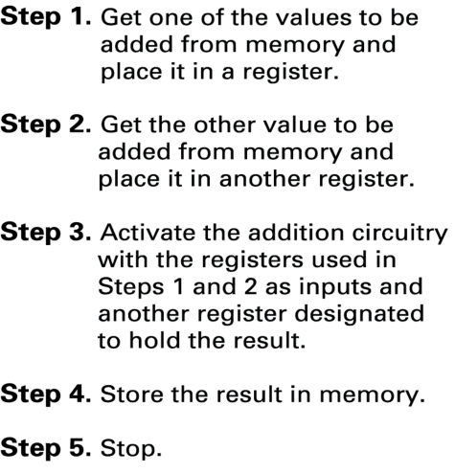
图2-2 主存储器中的值相加
步骤1 从存储器中取出一个要加的值放入一个寄存器中。
步骤2 从寄存器中取出另一个要加的值放入另一个寄存器中。
步骤3 激活加法电路，以步骤1和2所用的寄存器作为输入，用另一个寄存器存放相加的结果。
步骤4 将结果存入存储器。
步骤5 停止。

Figure 2.3 Dividing values stored in memory存储器中数值的除法运算
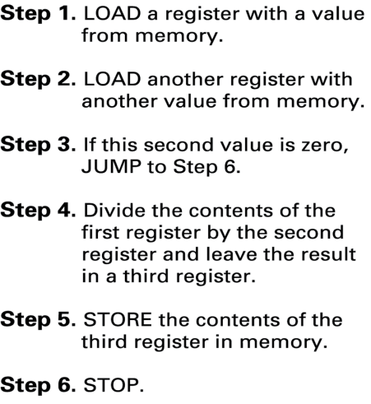
图2-3 存储器中数值的除法运算
步骤1 把存储器中的一个值加载到一个寄存器中。
步骤2 把存储器中的另一个值加载到另一个寄存器中。
步骤3 如果第二个值为0，那么转移到步骤6.
步骤4 第一个寄存器中的值除以第二个寄存器的值，结果留在第三个寄存器中。
步骤5 把第三个寄存器的值存储到存储器。
步骤6 停止。

Figure 2.6 Decoding the instruction 35A7指令35A7的译码
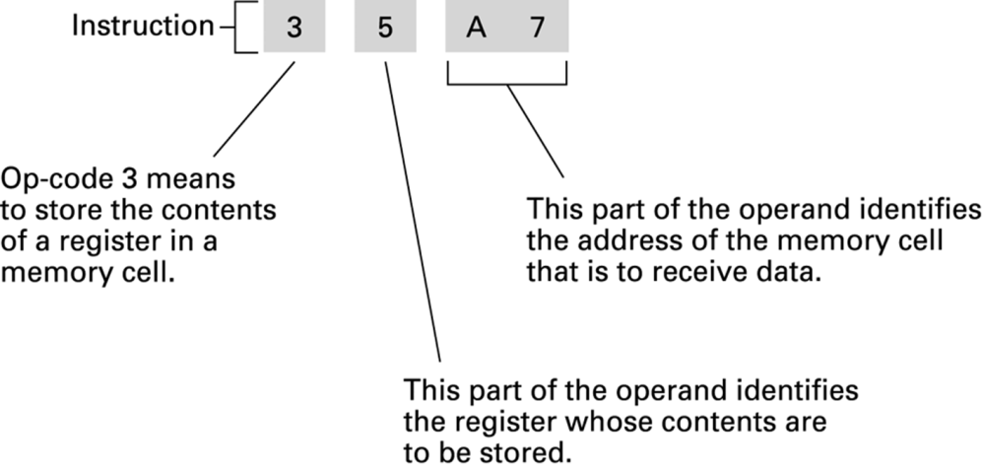
图2-6 指令35A7的译码
操作码3表示把一个寄存器中的内容存储到一个存储单元中
操作数的这部分标识接收数据的存储单元的地址
操作数的这部分标识哪个寄存器的值需要存储

Figure 2.7 An encoded version of the instructions in Figure 2.2图2-2中指令的编码形式
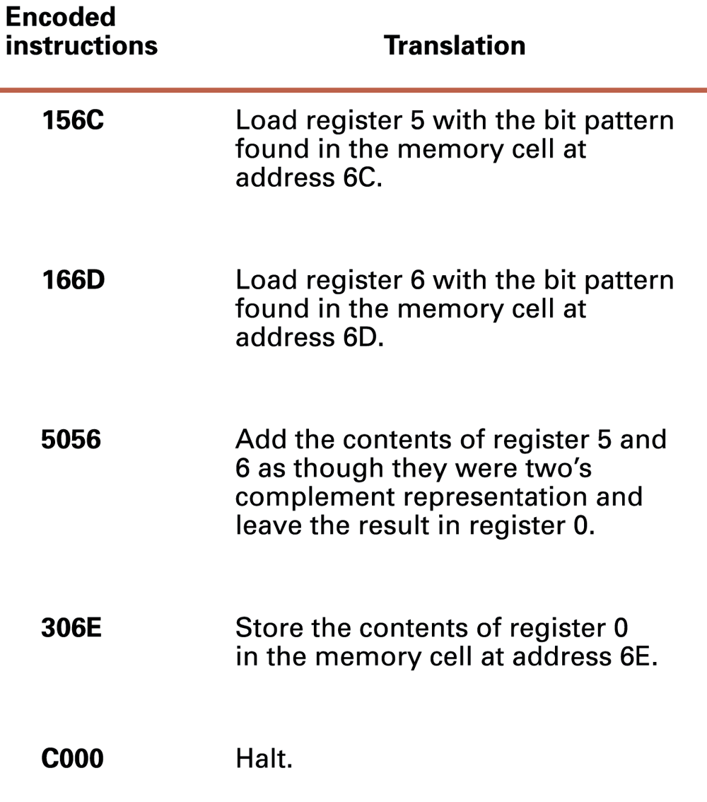
图2-7 图2-2中指令的编码形式
把地址为6C的存储单元里的位模式载入寄存器5
把地址为6D的存储单元里的位模式载入寄存器6
把寄存器5和6的内容按二进制补码表示相加，结果存入寄存器0
把寄存器0的内容存放到地址为6E的存储单元中
停止

Figure 2.8 The machine cycle
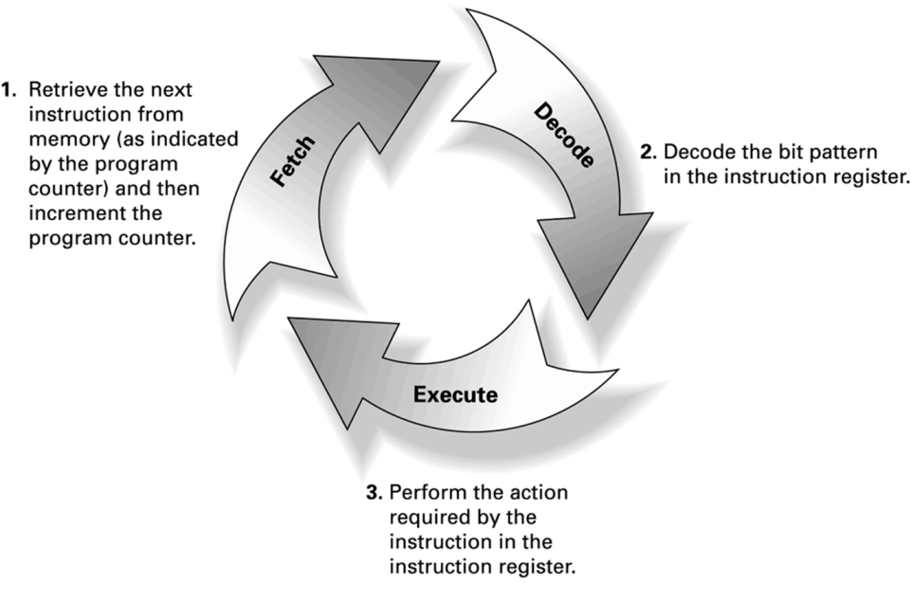
图2-8 机器周期
1. 根据程序计数器规定的地址从存储器中取下一条指令，然后增加程序计数器的值。
2. 对指令寄存器中的位模式进行译码。
3. 实现指令寄存器里指令所规定的动作。

Figure 2.9 Decoding the instruction B258指令B258的译码
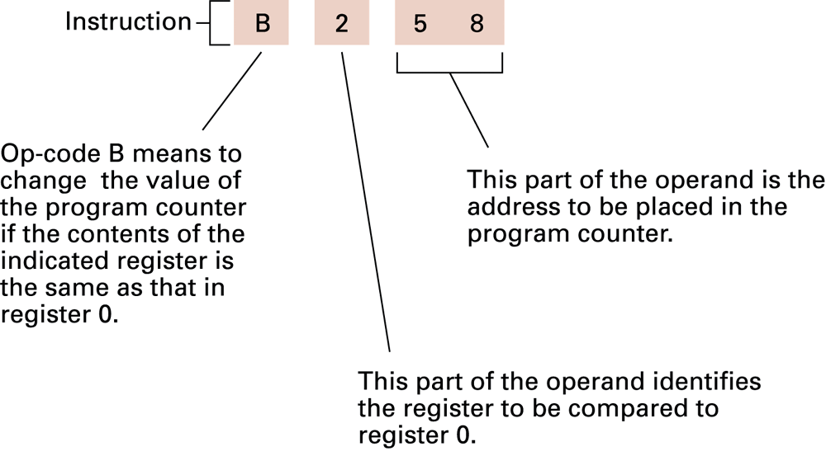
图2-9 指令B258的译码
操作码B表示，如果指定的寄存器的内容与寄存器0的内容相同，那么改变程序计数器的值。
操作数的这部分指示要与寄存器0进行比较的寄存器。
操作数的这一部分是要放在PC中的地址。

Chapter 3 Operating Systems
3.1 The History of Operating Systems
3.2 Operating System Architecture
3.3 Coordinating the Machine’s Activities
3.4 Handling Competition Among Processes
3.5 Security
第三章 操作系统
3.1 操作系统的历史
3.2 操作系统的体系结构
3.3 协调机器的活动
3.4 处理进程间的竞争
3.5 安全性

Chapter 4 Networking and the Internet
组网及因特网
4.1 Network Fundamentals网络基础
4.2 The Internet因特网
4.3 The World Wide Web万维网
*4.4 Internet Protocols因特网协议
4.5 Security安全性

Chapter 5 Algorithms
5.1 The Concept of an Algorithm
5.2 Algorithm Representation
5.3 Algorithm Discovery
5.4 Iterative Structures
5.5 Recursive Structures
5.6 Efficiency and Correctness

An algorithm is an ordered set of unambiguous, executable steps that defines a terminating process.
算法是（定义一个可终止过程的）一组有序的、无歧义的可执行的步骤的集合。

Polya’s Problem Solving Steps
1. Understand the problem.理解问题
2. Devise a plan for solving the problem.设计一个解决问题的计划
3. Carry out the plan.完成计划
4. Evaluate the solution for accuracy and its potential as a tool for solving other problems.从准确度及其是否有潜力作为一个工具解决其他问题这两方面来评估这个程序。

Figure 5.7 Components of repetitive control
可重复结构控制的组成
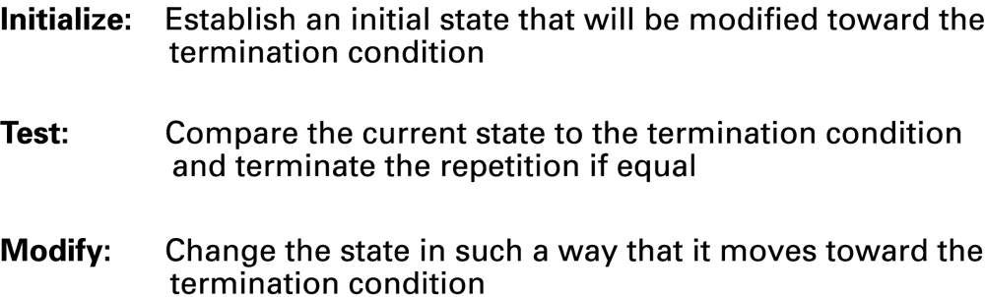
初始化：设置一个初始状态，这一状态将被修改直至终止条件（否则无法进入循环）
测试：比较当前状态和终止条件，如果相等则终止循环
修改：修改状态使之可以达到终止条件（否则死循环）

Recursion递归
The execution of a procedure leads to another execution of the procedure.
Multiple activations of the procedure are formed, all but one of which are waiting for other activations to complete.

What sequence of numbers would be printed by the following recursive procedure if we started it with N assigned the value 1?
Procedure Exercise(N)
print the value of N;
if (N<3) then (apply the procedure Exercise to the value N+1);
print the value of N.

Chapter 6 Programming Languages
In this chapter we study programming languages. Our purpose目标 is not to learn a particular language. Rather it is to learn about programming languages. We want to appreciate考察 the commonality共性 as well as the diversity个性 among programming languages and their associated methodologies.

6.1 Historical Perspective回顾
Early Generations早期程序设计语言
Machine Independence and Beyond独立并超越机器
Programming Paradigms程序设计范型
6.2 Traditional Programming Concepts传统的程序设计概念
Variables and Data Types变量和数据类型
Data Structure数据结构
Constants and Literals常量和字面量
Assignment Statements赋值语句
Control Statements控制语句
Comments注释
6.3 Procedural Units过程单元
Procedures过程
Parameters参数
Functions函数
6.4 Language Implementation语言实现
The Translation Process翻译过程
Software Development Packages软件开发包
6.5 Object-Oriented Programming面向对象程序设计
Classes and Objects类和对象
Constructors构造器
Additional Features附加特性

Chapter 7 Software Engineering
第7章 软件工程
7.1 The Software Engineering Discipline ['dɪsəplɪn] 326
7.1 软件工程学科211
7.2 The Software Life Cycle 329
7.2 软件生命周期213
The Cycle as a Whole
7.2.1 周期是个整体213
The Traditional Development Phase
7.2.2 传统的开发阶段214
7.3 Software Engineering Methodologies 334
7.3 软件工程方法216
7.4 Modularity 336
7.4 模块化217
Modular Implementation
7.4.1 模块的实现217
Coupling
7.4.2 耦合220
Cohesion
7.4.3 内聚221
Information Hiding
7.4.4 信息隐藏222
Components
7.4.5 构件222

7.5 Tools of the Trade 345
7.5 行业工具223
Some Old Friends
7.5.1 较老的工具223
Unified Modeling Language
7.5.2 统一建模语言224
Design Patterns
7.5.3 设计模式228
7.6 Quality Assurance 353
7.6 质量保证229
The Scope of Quality Assurance
7.6.1 质量保证的范围229
Software Testing
7.6.2 软件测试230
7.7 Documentation 357
7.7 文档编制231
7.8 The Human-Machine Interface 359
7.8 人机界面232
7.9 Software Ownership and Liability 362
7.9 软件所有权和责任234

Chapter 9 Database Systems
第9章 数据库系统
9.1 Database Fundamentals 418
9.1 数据库基础272
The Significance of Database Systems
9.1.1 数据库系统的重要性272
The Role of Schemas
9.1.2 模式的作用273
Database Management Systems
9.1.3 数据库管理系统274
Database Models
9.1.4 数据库模型275
9.2 The Relational Model 423
9.2 关系模型275
Issues of Relational Design
9.2.1 关系设计中的问题276
Relational Operations
9.2.2 关系运算279
SQL
9.2.3 SQL282
*9.3 Object-Oriented Databases 436
9.3 面向对象数据库284
*9.4 Maintaining Database Integrity 439
9.4 维护数据库的完整性286
The Commit/Rollback Protocol
9.4.1 提交/回滚协议286
Locking
9.4.2 锁定287
*9.5 Traditional File Structures 443
9.5 传统的文件结构288
Sequential Files
9.5.1 顺序文件288
Indexed Files
9.5.2 索引文件291
Hash Files
9.5.3 散列文件291
9.6 Data Mining 452
9.6 数据挖掘294
9.7 Social Impact of Database Technology 454
9.7 数据库技术的社会影响296

- 文章翻译（3*10’=30’）
Chapter 1 Data Storage
P19
In this chapter, we consider topics associated with data representation and the storage of data within a computer. The types of data we will consider研究 include text, numeric values, images图像, audio, and video. Much of the information in this chapter is also relevant to涉及 fields other than除了 traditional computing, such as digital photography数字摄影, audio/video recording音频/视频录制 and reproduction复制, and long-distance communication远程通信.
本章，我们将学习有关计算机中数据表示和数据存储的内容。我们要研究的数据类型包括文本、数值、图像、音频和视频。频/视频录制 and reproduction复制, and long-distance communication远程通信.除了传统计算外，本章的很多内容还涉及数字摄影，音频/视频录制和复制以及远程通信等领域。

P20
We begin our study of computer science by considering学习 how information is encoded编码 and stored inside computers. Our first step is to discuss讨论 the basics of a computer’s data storage devices数据存储设备 and then to consider研究 how information is encoded for storage in these systems. We will explore探讨 the ramifications分支 of today’s data storage systems and how such techniques as data compression and error handling are used to overcome their shortfalls不足.
The types of data we will consider研究 include text, numeric values, images图像, audio, and video. Much of the information in this chapter is also relevant to涉及 fields other than除了 traditional computing, such as digital photography[fə'tɑɡrəfi]数字摄影, audio/video recording音
我们首先要学习的是在计算机科学中信息如何编码和存储。第一步，我们要讨论计算机数据存储设备的基础知识，然后研究如何进行信息编码并将其存储到系统内部。我们还将探讨现如今数据存储系统的各个分支，以及如何用数据压缩、错误处理等技术来克服不足。
P20
Inside today’s computers information is encoded as patterns of 0s and 1s. These digits are called bits (short for binary digits). Although you may be inclined to倾向于 associate bits with numeric values, they are really only symbols whose meaning depends on the application at hand. Sometimes patterns of bits are used to represent numeric values; sometimes they represent characters字符 in an alphabet字母表 and punctuation marks; sometimes they represent images; and sometimes they represent sounds.
在今天的计算机中，信息是以0和1的模式编码的。这些数字称为位（bit, binary digits的缩写）。尽管你可能倾向于把它们与数值联系在一起，但它们的确只是些符号，其意义取决于正在处理的应用：有时用来表示数值；有时又代表字母表里的字符和标点符号；有时表示图像；有时还表示声音。
1.3 Mass Storage
P29
Due to the volatility and limited size of a computer’s main memory, most computers have additional memory devices called mass storage (or secondary storage) systems, including magnetic disks, CDs, DVDs, magnetic tapes, and flash drives (all of which we will discuss shortly不久). The advantages of mass storage systems over main memory include less volatility, large storage capacities, low cost, and in many cases, the ability to remove the storage medium from the machine for archival[ɑː'kaɪvəl] purposes.
The terms on-line and off-line are often used to describe devices that can be either attached to or detached from a machine. On-line means that the device or information is connected and readily available to the machine without human intervention. Off-line means that human intervention人为干预 is required before the device or information can be accessed by the machine—perhaps because the device must be turned on, or the medium holding the information must be inserted into some mechanism ['mek(ə)nɪz(ə)m].
A major disadvantage of mass storage systems is that they typically require mechanical motion and therefore require significantly more time to store and retrieve data than a machine’s main memory, where all activities are performed electronically.
由于计算机主存储器的不稳定性和容量的限制，大多数计算机都有称为海量存储系统的附加存储设备，包括磁盘、CD盘、DVD盘、磁带、闪存驱动器（所有这些稍后会讨论）。
相当于主存储器，海量存储系统的优点是更稳定、容量大、价格低，并且在许多情况下可以针对存档的需要从计算机上方便地取下这类存储设备。
术语联机和脱机通常分别用来描述那些既能接入计算机又能从计算机上移除的设备。
联机意味着设备或信息已经与计算机连接，不需要人的干预就可以使用。
脱机意味着必须先有人的干预，设备和信息才可被计算机使用——或许需要先打开这个设备，或许需要将包含该信息的介质插到某机械装置里。
海量存储系统的主要不足之处是，它们一般都需要机械运动。因为主存储器的所有工作都是由电子器件实现的，所以比起计算机主存储器来，海量存储系统的数据存取需要花费更长的时间。
P30
Several measurements标准 are used to evaluate a disk system’s performance: (1) seek time寻道时间 (the time required to move the read/write heads from one track to another); (2) rotation delay or latency time旋转延时或等待时间 (half the time required for the disk to make a complete rotation, which is the average amount of time required for the desired data to rotate around to the read/write head once the head has been positioned over the desired track); (3) access time存取时间 (the sum of seek time and rotation delay); and (4) transfer rate传输速率 (the rate at which data can be transferred to or from the disk).
有几个标准可以用来评估一个磁盘系统的性能：
寻道时间，读写磁头从一个磁道移到另一个磁道所需要的时间；
旋转延迟或等待时间，盘片旋转一周所需要时间的一半，也就是读写磁头到达所要求磁道后，等待盘片旋转使读写磁头位于所要存取的数据（扇区）上锁需要的平均时间；
存取时间，即寻道时间和等待时间之和。
传输时间，在磁盘上读出或写入数据的速率。
Chapter 2 Data Manipulation
第2章 数据操控
P73
In this chapter we will learn how a computer manipulates[məˈnɪpjəˌleɪt] data and communicates with peripheral devices such as printers and keyboards. In doing so, we will explore the basics of computer architecture and learn how computers are programmed by means of encoded instructions, called machine language instructions.
本章学习计算机如何操控数据以及如何与外围设备（如打印机和键盘）通信。为此，我们将研究计算机体系结构的基础知识，学习计算机是如何利用称为机器语言指令的编码指令来进行编程工作的。
In Chapter 1 we studied topics relating to the storage of data inside a computer. In this chapter we will see how a computer manipulates that data. This manipulation consists of moving data from one location to another as well as performing operations such as arithmetic calculations, text editing, and image manipulation. We begin by extending our understanding of computer architecture beyond that of data storage systems.
在第1章中，我们学习了有关计算机数据存储的主题，本章将介绍计算机如何操控这些数据，其内容包括数据在不同位置间的移动，以及诸如算术计算、文本编辑和图像处理等的操作。首先我们要了解除数据存储系统之外的计算机体系结构。
P77
Who Invented What?
谁的发明？
Awarding a single individual credit for an invention is always a dubious['dubiəs] undertaking. Thomas Edison is credited with inventing the incandescent[.ɪnkæn'des(ə)nt] lamp, but other researchers were developing similar lamps, and in a sense he was lucky to be the one to obtain the patent专利.
将某项发明的荣誉授予个人总是备受争议。人们将白炽灯的发明归功于托马斯.爱迪生，但是其他研究人员也曾研制了类似的灯泡，从某种意义上说，爱迪生只是比较幸运地获得了专利。
The Wright brothers are credited with被认为 inventing the airplane, but they benefited from the research of others, and to some degree, they were pre-empted[pri'empt] by Leonardo da Vinci, who toyed with the idea of flying machines in the fifteenth century. Even Leonardo's designs were apparently based on earlier ideas.
人们认为是莱特兄弟发明的飞机，但他们曾与其他人竞争并受益于其他人的研究，在某种程度上，他们又被达芬奇抢先了，他早在15世纪就有了玩玩飞行机器的想法。甚至达芬奇的设计看起来也是假借前人的思想。
Of course, in these cases the designated[ˈdezɪɡˌneɪtəd] inventor still has legitimate[lə'dʒɪtəmət] claims to the credit bestowed[bɪˈstoʊ]. In other cases, history seems to have awarded credit inappropriately[ˌɪnə'proʊprɪrtlɪ] -an example is the stored-program concept.
当然，对于这些发明，被认定的发明人还是有权拥有被授予的荣誉的。但对于其他一些情况，历史上的有些荣誉授予似乎是不恰当的，例如存储程序的概念。
Without a doubt, John von Neumann was a brilliant scientist who deserves credit for numerous contributions[.kɑntrɪ'bjuʃ(ə)n]. But the contribution for which popular history has chosen to credit him, the stored-program concept, was apparently developed by researchers led by J. P. Eckert at the Moore School of Electrical Engineering at the University of Pennsylvania. John von Neumann was merely the first to publish work reporting the idea and thus computing lore[lɔr] has selected him as the inventor[ɪnˈventər].
毫无疑问，约翰.冯.诺依曼是一位卓越的科学家，理应为自己的许多贡献获得荣誉。但是，历史选择授予他荣誉的贡献是存储程序概念，但这一思想很显然是由宾夕法尼亚大学莫尔电子工程学院以埃克特为首的研究人员提出的。约翰.冯.诺依曼不过是第一个在著作中转述这一思想的人，因此计算机界选择他作为发明人。
P85
Comparing Computer Power
比较计算机能力
When shopping[ˈʃɑpɪŋ] for a personal computer, you will find that clock speeds are often used to compare machines. A computer's clock is a circuit, called an oscillator['ɑsɪ.leɪtər], which generates pulses that are used to coordinate the machine's activities-the faster this oscillating circuit generates pulses, the faster the machine performs its machine cycle.
购买个人电脑通常用时钟速度来比较计算机。计算机的时钟是一个称为振荡器的电路，生成用于协调计算机活动的脉冲——该振荡器电路生成脉冲越快，则机器周期的执行速度也越快。
Clock speeds are measured in hertz (abbreviated as Hz) with one Hz equal to one cycle (or pulse) per second. Typical clock speeds in desktop computers are in the range of a few hundred MHz (older models) to several GHz. (MHz is short for megahertz, which is a million Hz. GHz is short for gigahertz, which is 1000 MHz.)
时钟速度以赫兹（缩写为Hz）为单位，1Hz相当于每秒1个周期（或脉冲）。台式计算机比较典型的时钟周期是几百MHz（较老的型号）到几GHz。（MHz是megahertz的缩写，1MHz=10⁶Hz,GHz是gigahertz的缩写,1GHz=1000MHz。）
Unfortunately, different CPU designs might perform different amounts of work in one clock cycle, and thus clock speed alone fails to be relevant in comparing machines with different CPUs.
不同的CPU设计在一个时钟周期里完成的工作量是不同的。因此，在比较具有不同CPU的计算机时，单单比较时钟速度没有太大意义。
If you are comparing a machine based on a PowerPC to one based on a Pentium['pentiəm], it would be more meaningful to compare performance by means of benchmarking, which is the process of comparing the performance of different machines when executing the same program, known as a benchmark[ˈbentʃˌmɑrk]. By selecting benchmarks representing different types of applications, you get meaningful comparisons for various market segments.
如果你在比较两台计算机，一台基于英特尔处理器，一台基于ARM处理器，那么采用基准测试来进行比较则更有意义。基准测试是指，在比较不同计算机时让它们执行同样的程序（称为基准），然后比较它们的性能。通过选择代表不同类型应用的基准，就能够从这些比较得到对各类市场有意义的结果。
P97
USB and FireWire
The universal serial bus (USB) and FireWire are standardized serial communication systems that simplify the process of adding new peripheral devices to a personal computer. USB was developed under the lead of Intel. The development of FireWire was led by Apple. In both cases the underlying theme is for a single controller to provide external ports at which a variety of peripheral devices can be attached.
USB（通用串行总线）和FireWire（火线）是标准化的串行通信系统，它们简化了给个人电脑添加外围设备的过程。USB由英特尔公司主导研发，FireWire则由苹果公司主导研发。两者的目的都是通过一个控制器提供外部端口，并用该端口来连接各种外围设备。
In this setting, the controller translates the internal signal characteristics of the computer to the appropriate USB or FireWire standard signals. In turn, each device connected to the controller converts its internal idiosyncrasies[.ɪdiə'sɪŋkrəsi] 特性to the same USB or FireWire standard, allowing communication with the controller. The result is that attaching a new device to a PC does not require the insertion of a new controller. Instead, one merely plugs any USB compatible device into a USB port or a FireWire compatible device into a FireWire port.
在该设置中，控制器将计算机内部信号特征转换成相应的USB或FireWire标准信号。反之，为了与控制器通信，与控制器相连接的每个设备都将其内部特性转换成相同的USB或FireWire标准。于是，给PC添加新设备就不再需要增加新的控制器，只需要在USB端口或FireWire端口插入分别与其兼容的设备。
Of the two, FireWire provides a faster transfer rate, but the lower cost of USB technology has made it the leader in the lower-cost mass market arena. USB compatible devices on the market today include mice, keyboards, printers, scanners, digital cameras, and mass storage systems designed for backup applications. FireWire applications tend to focus on devices that require higher transfer rates such as video recorders and online mass storage systems.
对比而言，FireWire的传输速率更高，但是USB技术成本低，因此在低成本大众市场领域占据突出地位。现在，市场上兼容USB的设备有鼠标、键盘、打印机、扫描仪、数码相机、智能手机，以及为备份应用设计的海量存储系统。FireWire应用趋向于集中在需要更高传输速率的设备上，例如摄像机和联机海量存储系统。
Chapter 3 Operating System
In this chapter we study operating systems, which are software packages that coordinate[kəʊ'ɔ:dɪneɪt] a computer’s internal[ɪn'tɜːn(ə)l] activities as well as oversee检查 its communication with the outside world. It is a computer’s operating system that transforms转换 the computer hardware into a useful tool. Our goal is to understand what operating systems do and how they do it. Such a background is central to being an enlightened computer user.
P112
If interactive systems had been required to serve only one user at a time, real-time processing would have been no problem. But computers in the 1960s and 1970s were expensive, so each machine had to serve more than one user. In turn, it was common for several users, working at remote terminals, to seek interactive service from a machine at the same time, and real-time considerations presented obstacles. If the operating system insisted on executing only one job at a time, only one user would receive satisfactory real-time service.
The solution to this problem was to design operating systems that provided service to multiple users at the same time: a feature called time-sharing. One means of implementing time-sharing is to apply the technique called multiprogramming in which time is divided into intervals and then the execution of each job is restricted to only one interval at a time. At the end of each interval, the current job is temporarily set aside and another is allowed to execute during the next interval. By rapidly shuffling the jobs back and forth in this manner, the illusion of several jobs executing simultaneously [,sɪml'teɪnɪəslɪ] is created. Depending on the types of jobs being executed, early time-sharing systems were able to provide acceptable real-time processing to as many as 30 users simultaneously. Today, multiprogramming techniques are used in single-user as well as multiuser systems, although in the former the result is usually called multitasking. That is, time-sharing refers to multiple users sharing access to a common computer, whereas multitasking refers to one user executing numerous tasks simultaneously.
P113
In short总之, operating systems have grown from simple programs that retrieved获取 and executed programs one at a time into complex systems that coordinate timesharing, maintain programs and data files in the machine’s mass storage devices, and respond directly to requests from the computer’s users.
What’s in a Smartphone?
As cell phones have become more powerful, it has become possible for them to offer services well beyond simply processing voice calls. A typical smartphone can now be used to text message, browse the Web, provide directions, view multimedia content—in short简而言之, it can be used to provide many of the same services as a traditional PC. As such因此, smartphones require full-fledged成熟的 operating systems, not only to manage the limited resources of the smartphone hardware, but also to provide features that support the rapidly expanding collection of smartphone application software.
The battle for dominance统治 in the smartphone operating system market place promises to be fierce and will likely be settled on the basis of which system can provide the most imaginative有创意的 features at the best price.智能手机操作系统市场的争夺之战将日趋激烈，而争夺的焦点很有可能在于哪个操作系统可以以最优的价格提供最有创意的功能。 Competitors in the smartphone operating system arena include Apple’s iPhone OS, Research In Motion’s BlackBerry OS, Microsoft’s Windows Phone, Nokia’s Symbian OS, and Google’s Android.
P116
Linux
For the computer enthusiast爱好者[ɪn'θjuːzɪæst; en-] who wants to experiment with the internal components of an operating system, there is Linux. Linux is an operating system originally designed by Linus['lainəs] Torvalds while a student at the University of Helsinki. It is a nonproprietary非专利 product and available, along with its source code (see Chapter 6) and documentation, without charge. Because it is freely available in source code form, it has become popular among computer hobbyists业余爱好者, students of operating systems, and programmers in general. Moreover而且, Linux is recognized ['rekəg'naɪzd] as one of the more reliable可靠的 operating systems available today. For this reason, several companies公司 now package包装 and market versions of Linux in an easily useable实用的 form, and these products are now challenging the long-established长期被认可的 commercial operating systems on the market. You can learn more about Linux from the Web site at http://www.linux.org.
P118
For the convenience of the machine’s users计算机用户, most file managers文件管理程序 allow files to be grouped into a bundle called a directory or folder. This approach方法 allows a user to organize his or her files according to their purposes by placing related files in the same directory. Moreover, by allowing directories to contain other directories, called subdirectories, a hierarchical层次 organization can be constructed.
P119
The task of the memory manager is complicated further when the total main memory space required exceeds the space actually available in the computer. In this case the memory manager may create the illusion of additional memory space by rotating programs and data back and forth between main memory and mass storage (a technique called paging). Suppose, for example, that a main memory of 8GB is required but the computer only has 4GB. To create the illusion of the larger memory space, the memory manager reserves预留 4GB of storage space on a magnetic disk. There it records the bit patterns that would be stored in main memory if main memory had an actual capacity of 8GB. This data is divided into uniform统一的 sized units called pages, which are typically a few KB in size. Then the memory manager shuffles these pages back and forth between main memory and mass storage so that the pages that are needed at any given time are actually present in the 4GB of main memory. The result is that the computer is able to function as though it actually had 8GB of main memory. This large “fictional虚构的” memory space created by paging分页技术 is called virtual memory.
P122
The Concept of a Process
One of the most fundamental concepts of modern operating systems is the distinction between a program and the activity of executing a program执行程序的活动. The former is a static set of directions, whereas the latter is a dynamic activity whose properties change as time progresses. (This distinction is analogous [ə'næləgəs] to a piece of sheet music活页乐谱, sitting inert in a book on the shelf, versus a musician performing that piece by taking actions that the sheet music describes.) The activity of executing a program under the control of the operating system is known as a process. Associated with a process is the current status of the activity, called the process state. This state includes the current position in the program being executed (the value of the program counter) as well as the values in the other CPU registers and the associated memory cells. Roughly speaking大约说来, the process state is a snapshot of the machine at a particular time. At different times during the execution of a program (at different times in a process) different snapshots (different process states) will be observed.
Unlike a musician, who normally tries to play only one musical piece at a time, typical time-sharing/multitasking computers are running many processes, all competing for the computer’s resources. It is the task of the operating system to manage these processes so that each process has the resources (peripheral devices, space in main memory, access to files, and access to a CPU) that it needs, that independent processes do not interfere with one another, and that processes that need to exchange information are able to do so.

Chapter 4 Networking and the Internet
In this chapter we discuss the area of computer science known as networking组网, which encompasses [ɪn'kʌmpəs; en-] the study of how computers can be linked together to share information and resources. Our study will include the construction [kənˈstrʌkʃən]结构 and operation of networks, applications of networks, and security issues. A prominent[ˈprɑ:mɪnənt]重点 topic主题 will be a particular worldwide network of networks known as the Internet.
本章讨论计算机科学中称为组网的领域，包括学习如何将计算机连接起来共享信息和资源。
学习的内容包括网络的结构与操作、网络的应用以及网络安全问题。学习的一个重点主题是遍布世界范围的特殊网络——因特网。
P140
The need to share information and resources among different computers has led to催生 linked computer systems, called networks网络, in which computers are connected so that data can be transferred from machine to machine. In these networks, computer users can exchange messages and share resources—such as printing capabilities, software packages, and data storage facilities [fəˈsɪləti]数据存储设备—that are scattered分布 throughout [θruː'aʊt] the system. The underlying software required to support such applications has grown from simple utility packages into an expanding system of network software that从而 provides a sophisticated [səˈfɪstɪˌketɪd]
network-wide infrastructure基础架构. In a sense从某种意义上说, network software is evolving发展 into a network-wide operating system. In this chapter we will explore this expanding不断发展的 field of computer science.
人们对不同计算机之间共享信息和资源的需求催生了相互连接的计算机系统，它被称为网络。计算机通过网络连接在一起，数据可以从一台计算机传输到另一台计算机。在网络中，计算机用户可以相互交换信息，并且可以共享分布在整个网络系统中的资源，如打印功能、软件包以及数据存储设备。用于支持这类应用的基础软件也已经从简单的实用软件升级为扩展网络软件系统，从而可以提供一个复杂的网络范围的基础架构。从某种意义上说，网络软件正发展成为网络范围的操作系统。本章将探讨计算机科学中这个不断发展的领域。
P148
Distributed Systems
With the success of networking technology, interaction between computers via networks has become common and multifaceted涉及方方面面. Many modern software systems, such as global information retrieval systems, company-wide accounting会计 and inventory库存 systems, computer games, and even the software that controls a network’s infrastructure itself are designed as distributed systems, meaning that they consist of software units that execute as processes on different computers.
因为组网技术的成功，计算机之间通过网络的交互已经很普遍，并且涉及方方面面。许多现代软件系统，例如全球信息检索系统、公司范围的会计和库存系统、计算机游戏甚至操控网络设施本身的软件，都被设计成分布式系统。这意味着，它们由在网络中不同计算机上作为进程执行的软件单元组成。
Early distributed systems were developed independently from scratch最开始. But today, research is revealing揭示 a common infrastructure running throughout these systems, including such things as communication and security systems.
分布式系统最开始是独立开发的。不过，今天的研究已经发现在这些系统之间可以使用公共的基础设施，例如通信系统以及安全系统。
In turn于是, efforts have been made to produce prefabricated[ˌpri:ˈfæbrɪkeɪtɪd]预制的 systems that provide this basic infrastructure and therefore allow distributed applications to be constructed by merely developing the part of the system that is unique特有的 to the application.
于是，人们开始努力生产能够提供这种基础设施的预制系统。因此要构建一个分布式应用，只需要开发系统中应用所特有的部分即可。
Several types of distributed computing systems are now common.
现在，一些类型的分布式计算系统已经很常见。
Cluster computing集群计算 describes a distributed system in which many independent computers work closely together to provide computation or services comparable比拟 to a much larger machine.
集群计算指的是一种分布式系统，其中多个独立的计算机密切合作，提供的计算和服务可与大得多的机器相比拟。
The cost of these individual machines, plus the high-speed network to connect them, can be less than a higher-priced supercomputer, but with higher reliability [rɪˌlaɪəˈbɪlətɪ] and lower maintenance [ˈmentənəns] costs.
这些独立的机器，加上连接它们的高速网络的总成本，要比一台高价位的超级计算机的成本低，但其可靠性更高，且维护成本更低。
Such distributed systems are used to provide high-availability[əˌveləˈbɪlətɪ]高可用性—because it is more likely that at least one member of the cluster will be able to answer a request, even if other cluster members break down or are unavailable—and load-balancing负载平衡—because the workload can be shifted automatically from members of the cluster that have too much to do to those that may have too little.
这样的分布式系统用于提供高可用性（因为这更有可能保证集群中至少有一台计算机可以响应请求，即使集群中其他计算机发生故障或不可用）和负载平衡（因为负载可以自动从集群中负载太大的计算机转移到负载很小的计算机上）。
Grid computing网格计算 refers to distributed systems that are more loosely coupled than clusters but that still work together to accomplish[əˈkɑ:mplɪʃ] large tasks.
网格计算是指与集群相比耦合度不高的分布式系统，但其成员机器仍共同协作来完成大型任务。
Grid computing can involve specialized software to make it easier to distribute data and algorithms to the machines participating in a grid.
网格计算可能需要专门的软件，以便更容易地发布数据和算法到网格中的计算机。
Examples include University of Wisconsin’s Condor system, or Berkeley’s Open Infrastructure for Network Computing (BOINC). Both of these systems are often installed on computers that are used for other purposes, such as PCs at work or at home, that can then volunteer computing power to the grid when the machine is not otherwise being used.
威斯康星大学的Condor系统和BOINC（伯克利开放式网络计算平台）都属于这种类型。这两种系统通常安装在用于其他目的的计算机上（如办公用PC和家用PC），当机器空闲时便可为网格自愿提供计算能力。
Enabled by the growing connectivity of the Internet, this type of voluntary, distributed grid computing has enabled millions of home PCs to work on enormously complex mathematical and scientific problems.
由于因特网日益增强的连通性，即这种自愿行动，分布式网格计算使得数以百万计的家用PC都可以解决无比复杂的数学问题和科学问题。
Cloud computing云计算, whereby通过 huge pools of shared computers on the network can be allocated for use by clients as needed, is the latest trend in distributed systems.
凭借云计算，网络上大量的共享计算机得以被按需分配给客户机使用。云计算是分布式系统中的最新趋势。
Much as the spread of metropolitan electrical grids in the early twentieth century eliminated the need for individual factories and businesses to maintain their own generators, the Internet is making it possible for entities to entrust委托 their data and computations to “the Cloud,” which in this case refers to the enormous computing resources already available on the network.
20世纪初大城市电网的发展使得个体工厂和企业不再需要维护自己的发电机，与此非常类似，因特网使得实体可以将其数据和计算委托给“云”，这里的“云”指的是网络上可用的大量计算资源。
Services such as Amazon’s Elastic弹性 Compute Cloud allow clients to rent virtual computers by the hour, without concern for where the computer hardware is actually located.
例如，亚马逊的弹性计算云服务允许客户按小时租用虚拟计算机，而不需要考虑计算机硬件的实际位置。
Google Docs and Google Apps allow users to collaborate [kəˈlæbəˌret]协作 on information or build Web services without needing to know how many computers are working on the problem or where the relevant data are stored.
另外，Google Docs and Google Apps 允许用户在信息方面进行协作，允许他们在构建Web服务时不需要了解多少台计算机在用于求解同一问题或相关数据存储在何处。
Cloud computing services provide reasonable guarantees合理保证 of reliability and scalability可扩展性, but also raise concerns about privacy隐私 and security in a world where we may no longer know who owns and operates the computers that we use.
云计算服务就可靠性和可扩展性提供了合理保证，但却引发了人们对于隐私和安全性的担忧，因为我们也许再无法知晓谁在拥有着、操作着我们所用的计算机。

P151
The technology by which end systems终端系统 connect to access ISPs is also varied. Perhaps the fastest growing are wireless connections based on WiFi technology.
终端系统与因特网接入服务提供商连接的技术也不尽相同。或许，发展最快的是基于WiFi技术的无线连接。
The strategy is to connect the AP接入点 to an access ISP and thus provide Internet access through that ISP to end systems within the AP’s broadcast range.
策略是将接入点与因特网接入服务提供商相连接，因此可以在接入点的广播范围内通过因特网接入服务提供商向终端系统提供因特网接入。
The area within the AP’s range is often called a hot spot. Hot spots and groupings of hot spots are becoming quite prevalent流行的, ranging from individual residences, hotel and office buildings, small businesses, parks, and in some cases entire cities.
接入点范围内的区域通常称为热点。热点与热点组的范围日益广泛，包括个人住宅、酒店和写字楼、小型企业、公园，甚至有些情况下是整个城市。
A similar technology is used by the cellular telephone industry where hot spots are known as cells and the “routers” generating the cells are coordinated to provide continuous service as an end system moves from one cell to another.
目前手机行业也使用相似的技术，在手机行业中热点就是我们所知的服务区，当终端系统从一个服务区移动到另一个服务区时，通过调整产生服务区的“路由器”来提供连续的服务。
P151
INTERNET 2第二代因特网
Now that the Internet has shifted from a research project to a household commodity日常用品, the research community has moved on to a project called Internet2.
既然因特网已经由科研项目转变成一种日常用品，科研界于是转向了称为第二代因特网的项目。
Internet2 is intended as an academic-only system and involves numerous universities working in partnership with industry and government.
他们打算将其定位于学术系统，涉及许多与工业及政府有合作关系的大学。
The goal is to conduct research in internet applications requiring high bandwidth communication, such as remote access and control of costly state-of-the-art最先进的 equipment such as telescopes and medical diagnostic devices.
目标是在需要高带宽的因特网应用中进行科研，包括远程访问及控制昂贵的最新型设备，例如望远镜和医学诊断仪器。
An example of current research involves remote surgery外科 performed by robot hands that mimic模仿 the hands of a distant surgeon who views the patient by video. You can learn more about Internet2 at http://www.internet2.org.
现在的一个科研例子是：由机器人实施远程外科手术，机器人的手模仿远程外科医生的手，而外科医生通过视频观察病人。你可以通过网站http://www.internet2.org了解到更多关于第二代因特网的信息。
P156
The Generations of Wireless Telephones无线电话
无线电话的演进
In the past decade mobile phone technology has advanced from simple, single purpose专用, portable devices便携设备 to complex, multifunction hand-held手持 computers.
在过去的10年时间里，移动电话技术已经从简单的专用便携设备发展为复杂的多功能手持式计算机。
The first generation wireless telephone network transmitted analog voice signals模拟语音信号 through the air, much like traditional telephones but without the copper wire running through the wall. In retrospect回顾, we call these early phone systems “1G,” or first generation, networks.
第一代无线电话网络通过空气传输模拟语音信号，与传统的电话系统非常相似，只是没有穿墙而过的铜线。我们把这些早期的电话系统称为“1G”网络，即第一代网络。
The second generation used digital signals to encode voice, providing more effective use of the airwaves无线电波 and the transmission of other kinds of digital data such as text messaging.
第二代网络使用数字信号对语音编码，能够更高效地使用无线电波，还能够传输其他种类的数字数据，如文本消息。
Third generation (“3G”) phone network provides higher data transfer rates, allowing for mobile video calls and other bandwidth-intensive带宽密集型 activities.
第三代电话网络提供了更高的数据传输速率，支持手机视频通话和其他带宽密集型活动。
The 4G network objectives include even higher data transfer rates, and a fully packet-switched完全进行分组交换 network using the IP protocol, which will provide the newest generation of smartphones with the capabilities currently available only to broadband-enabled基于宽带的 PCs.
4G网络目标包括更高的数据传输速率和一个使用IP协议完全进行分组交换的网络（以这个网络为基础的最新一代智能手机将能够具有当前仅在基于宽带的PC上可用的功能）。
Chapter 5 Algorithms
In the introductory [ˌɪntrəˈdʌktəri] 绪论 chapter we learned that the central theme核心主题 of computer science is the study of algorithms[ˈælɡəˌrɪðəm] . It is time now for us to focus on关注 this core topic. Our goal is to explore探究 enough of this foundational[faʊn'deɪʃənəl] material so that we can truly understand and appreciate [əˈpriʃiˌet] 认识 the science of computing计算科学.
在“绪论”一章中我们得知，计算机科学的核心主题是对算法的研究。现在是我们关注这个核心主题的时候了。我们的目标是探究足够的基本素材来真正地理解和认识计算科学。
We have seen知道 that before a computer can perform a task, it must be given an algorithm telling it precisely[prɪˈsaɪs] what to do; consequently因此, the study of algorithms is the cornerstone基石 of computer science. In this chapter we introduce many of the fundamental concepts of this study课题, including the issues of algorithm discovery and representation as well as the major control concepts of iteration and recursion. In so doing在讲解这些的同时 we also present介绍 a few well-known algorithms几个著名算法 for searching and sorting. We begin by reviewing介绍 the concept of an algorithm.
我们已经知道，在计算机能够执行一个任务之前，必须给出一个算法精确地告诉计算机做什么。因此，算法的研究是计算机科学的基石。在本章中，我们将介绍算法研究的许多基本概念，包括算法的发现和表示以及算法的主要控制结构——迭代和递归等问题。在讲解这些问题的同时，我们还会介绍几个有关查找和排序的著名算法。下面首先介绍算法的概念。
P192
Computer science approaches these problems by establishing a well-defined set of building blocks from which algorithm representations can be constructed. Such a building block is called a primitive.
计算机科学解决这些问题的途径是建立一组严格定义的构建块，利用它们来构建算法的表示。这种构建块称作原语。
Assigning precise definitions to these primitives removes消除 many problems of ambiguity[ˌæmbɪˈɡjuɪti]歧义, and requiring algorithms to be described in terms of按照 these primitives establishes确定 a uniform level of detail.
赋予原语准确的定义消除了很多由于歧义造成的问题，并且要求按照这些原语来描述算法就是确定了一致的细致程度。
A collection of primitives along with a collection of rules stating how the primitives can be combined to represent more complex ideas constitutes构成 a programming language.
原语的集合以及说明如何组合这些原语来表示比较复杂的想法的规则集合就构成了一种程序设计语言。
Each primitive has its own syntax[ˈsɪnˌtæks] and semantics [sɪ'mæntɪk]. Syntax refers to the primitive’s symbolic representation; semantics refers to the meaning of the primitive.
The syntax of air consists of three symbols, whereas the semantics is a gaseous [ˈɡæsiəs, ˈɡæʃəs]气态的 substance that surrounds充满 the world. As an example, Figure 5.3 presents some of the primitives used in origami[ˌɔ:rɪˈgɑ:mi] 折纸手工.
每个原语都有自己的语法和语义。语法是原语的符号表示，语义是指该原语的含义。Air一词的语法由3个符号组成，然而其语义是一种充满整个世界的气体物质。作为例子，图5-3描述了折纸术中使用的一些原语。
To obtain a collection of primitives to use in representing algorithms for computer execution, we could turn to the individual个别的 instructions指令 that the machine is designed to execute. If an algorithm is expressed at this level of detail, we will certainly have a program （suitable for machine execution）.
为了获得用来描述由计算机执行的算法的原语的集合，我们需要借助于计算机执行的单个指令。如果一个算法在这个级别上加以描述，我们肯定会得到一个适合计算机执行的程序。
However, expressing algorithms at this level is tedious单调的, and so one normally uses a collection of “higher-level” primitives, each being an abstract tool constructed from the lower-level primitives provided in the machine’s language.
然而，在这个级别上描述的算法是非常单调的，所以我们一般使用一些“更高级”的原语，其中每个原语都是由机器语言提供的较低级的原语组成的抽象工具。
The result is a formal programming language in which algorithms can be expressed at a conceptually概念上 higher level than in machine language. We will discuss such programming languages in the next chapter.
因此，我们可以得到一个概念上比机器语言更高级的方式来描述算法的正式的程序设计语言。我们将在下一章中讨论这种程序设计语言。
P197
Naming Items in Programs命名程序中的项
In a natural language, items often have multiword names such as “cost of producing a widget” or “estimated arrival time.” Experience has shown that经验表明 use of such multiword names in the representation of an algorithm can complicate [ˈkɑ:mplɪkeɪt] the algorithm’s description. It is better to have each item identified by a single contiguous block of text.
在自然语言中，项通常使用多个单词的名称，例如：“cost of producing a widget”或“estimated arrival time”。经验表明，在一个算法表示中使用这种多个单词的名称会使算法的描述复杂化。最好让每个项使用一个连续的文本块指示。
Over the years many techniques have been used to compress multiple words into a single lexical unit词法单元 to obtain descriptive names for items in programs.
多年来，许多技术被用于将多个单词紧缩为单个词法单元，以便为程序中的项提供描述性名称。
One is to use underlines to connect words, producing names such as estimated_arrival_time. Another is to use uppercase letters to help a reader comprehend [ˌkɑ:mprɪˈhend] 理解 a compressed multiword name.
一种技术是使用下划线来连接单词，建立诸如estimated_arrival_time这样的名称。另一种技术是用大写字母帮助读者理解紧缩的多单词名称。
For example, one could start each word with an uppercase letter to obtain names such as EstimatedArrivalTime. This technique is called Pascal casing, because it was popularized by users of the Pascal programming language. A variation of Pascal casing is called camel casing, which is identical to Pascal casing except that the first letter remains in lowercase as in estimatedArrivalTime. In this text we lean toward Pascal casing, but the choice is largely a matter of taste.
例如，我们可以对每个单词的首字母使用大写，获得诸如EstimatedArrivalTime这样的名称。这种技术称为Pascal样式，因为该样式在Pascal程序设计语言的用户中很流行。一种Pascal样式的变形称为camel样式，该样式除了首字母小写外，其他与Pascal样式相同，如estimatedArrivalTime。本书中，我们使用Pascal样式，但这种选择很大程度上是个人偏好。
P204
5.4 Iterative Structures迭代结构
Our goal now is to study some of the repetitive structures used in describing algorithmic processes. In this section we discuss iterative structures in which a collection of instructions is repeated in a looping manner.
我们现在要学习一些在描述算法过程中使用的重复结构。在本节中，我们讨论迭代结构。在这种结构中，一组指令以循环方式重复执行。
In the next section we will introduce the technique of recursion. As a side effect关联知识, we will introduce some popular algorithms—the sequential search, the binary search, and the insertion sort. We begin by introducing the sequential search algorithm.
在下节中，我们将介绍递归技术。作为一些关联知识，我们将介绍一些流行的算法——顺序搜索法、二分搜索法和插入排序法。我们从介绍顺序搜索法开始。
P214
5.5 Recursive Structures递归结构
Recursive structures provide an alternative[ɔ:lˈtɜ:rnətɪv] to the loop paradigm [ˈpærədaɪm]循环模型 for implementing the repetition [ˌrɛpɪˈtɪʃən] of activities. Whereas a loop involves repeating a set of instructions in a manner in which the set is completed and then repeated, recursion involves repeating the set of instructions as a subtask of itself.
递归结构提供了除循环模型以外用来实现重复活动的另外一种选择。循环涉及重复一个指令集，其方式是执行完成一组指令，然后重复执行，而递归则是通过将指令集作为自身的一个子任务重复调用来运行的。
As an analogy [əˈnælədʒi] 打个比方, consider the process of conducting telephone conversations with the call waiting feature. There, an incomplete telephone conversation is set aside while another incoming call is processed. The result is that two conversations take place. However, they are not performed one-after-the-other as in a loop structure, but instead one is performed within the other.
在处理来电的过程中，呼叫等待的特性就是一个很好的递归例子。在这个例子中，当处理另外一个来电的时候，先前未完成的通话将被搁置一边，结果是一共进行了两次通话。然而，这两次通话并不是以那种先执行一个然后再执行一个的类似于循环结构的方式完成的，而是一次通话在另外一次通话过程中进行。
Chapter 6 Programming Languages 片段
In this chapter we study programming languages. Our purpose目标 is not to learn a particular language. Rather it is to learn about programming languages. We want to appreciate考察 the commonality共性 as well as the diversity个性 among programming languages and their associated methodologies.
本章我们来学习程序设计语言。我们的目标并不是学习一门特定的程序设计语言，而是学习与程序设计语言相关的一些知识。我们将要考察程序设计语言及其相关联的方法之间的共性和个性。

The development of complex software systems such as operating systems, network software, and the vast array of大型 application software available today would likely be impossible if humans were forced to write programs in machine language.
如果人们不得不使用机器语言直接编写程序，那么要想开发操作系统、网络软件和大型应用软件这样的复杂软件系统基本上是不可能的。
Dealing with the intricate复杂的 detail associated with such languages while trying to organize complex systems would be a taxing experience繁重的工作, to say the least.
我们至少可以这么说，在试图组织和设计一个复杂系统的同时，处理这些与机器语言有关的繁琐而复杂的细节必定是一项繁重的工作。
Consequently因此, programming languages similar to our pseudocode have been developed that allow algorithms to be expressed in a form that is both palatable理解 to humans and easily convertible转换 into machine language instructions.
因此，类似伪代码的程序设计语言开发出来了，它使得算法既方便人理解，又能够很方便地转换为机器指令。
Our goal in this chapter is to explore the sphere领域 of computer science that deals with the design and implementation of these languages.
本章，我们的目标是考查计算机科学领域内这些程序设计语言的设计和实现。
P247
Still another programming paradigm程序设计范型 (and the most prominent著名的 one in today’s software development) is the object-oriented paradigm面向对象范型, which is associated with the programming process called object-oriented programming (OOP).
还有另一种程序设计范型（当今的软件开发领域中最著名的一个）是面向对象范型，它是与称为OOP(Object-Oriented Programming，面向对象程序设计)的程序设计过程相联系的。
Following this paradigm, a software system is viewed as 被看做a collection of units, called objects, each of which is capable of performing the actions that are immediately related to itself as well as requesting actions of other objects. Together, these objects interact to solve the problem at hand.
遵照该范型，一个软件系统被看作是对象的集合，每一个对象都能够执行与自己直接相关的动作以及其他对象请求的动作。总之，这些对象通过交互解决问题。
As an example of the object-oriented approach at work, consider the task of developing a graphical user interface. In an object-oriented environment, the icons that appear on the screen would be implemented as objects.
再举一个面向对象方法的例子，考虑一个开发图形用户界面的工作。在面向对象环境中，屏幕上的图标将作为对象来实现。
Each of these objects would encompass a collection of procedures (called methods in the object-oriented vernacular环境) describing how that object is to respond to the occurrence of various events, such as being selected by a click of the mouse button or being dragged across the screen by the mouse. Thus the entire system would be constructed as a collection of objects, each of which knows how to respond to the events related to it.
每个对象包含了一组过程（在面向对象环境中称为方法），这些过程描述了对象是如何响应各种事件的发生的，诸如被鼠标单击选中或者是被鼠标在屏幕上拖动等。因此，整个系统是对象的集合，每一个对象都知道如何响应与之有关的事件。
P250
Scripting Languages
脚本语言
A subset of一部分 the imperative programming languages命令编程语言 is the collection of languages known as scripting languages脚本语言. These languages are typically used to perform administrative tasks rather than to develop complex programs. The expression of such a task is known as a script, which explains the term “scripting language.”
一部分命令编程语言是称为脚本语言的语言集合。这些语言通常用来执行管理任务，而不是开发复杂的程序。这种任务的表述称为脚本，它解释了术语“脚本语言”。
For example, the administrator of a computer system might write a script to describe a sequence of record-keeping activities that should be performed every evening, or the user of a PC might write a script to direct the execution of a sequence of programs required to read pictures from a digital camera, index the pictures by date, and store copies of them in an archival storage system.
例如，计算机系统的管理员也许会写一个脚本来描述一系列每晚执行的需要保持记录的活动，而PC的用户也许会写一个脚本来指导一系列程序的执行，以从数码相机中读取照片，通过日期对照片建立索引，以及在档案存储系统中存储照片的副本。
The origin of scripting languages can be traced to the job control languages of the 1960s that were used to direct an operating system in the scheduling调度 of batch processing jobs (see Section 3.1). Even today, many consider scripting languages to be languages for directing the execution of other programs, which is a rather restrictive局限的 view of current scripting languages.
脚本语言的起源可以追溯到20世纪60年代的作业控制语言，当时在批处理作业的调度中它被用于指导操作系统（参看3.1节）。甚至在今天，许多人都认为脚本语言是指导其他语言执行的语言，这就对现在的脚本语言的认识产生了局限性。
Examples of scripting languages include Perl and PHP, both of which are popular in controlling server-side Web applications (see Section 4.3), as well as VBScript, which is a dialect of Visual Basic that was developed by Microsoft and is used in Windows-specific situations环境.
脚本语言的例子包括Perl和PHP，二者在控制服务器Web应用（参看4.3节）和VBScript中都很常见，VBScript是Visual Basic的非标准语言，它是由微软开发的并用于Windows的特定环境下。
P257
Programming Language Cultures程序设计语言文化
As with natural languages, users of different programming languages tend to develop cultural differences and often debate the merits优劣 of their perspectives.
就像自然语言一样，不同程序设计语言的使用者往往会开创出不同的文化，并且经常站在各自的观点上争论语言之间的优劣。
Sometimes these differences are significant显著的 as, for instance, when different programming paradigms are involved涉及不同的程序设计范型时. In other cases, the distinctions are subtle.
有时候这些区别是显著的，如涉及不同的程序设计范型时，而其他情况中，这种差异却很微妙。
For example, whereas the text distinguishes between procedures and functions (Section 6.3), C programmers refer to both as functions. This is because a procedure in a C program is thought of as a function that does not return a value.
比如，尽管过程和函数在字面上存在差异（6.3节），但是C语言程序员把这两者都称为函数。这是因为在一个C程序中，过程被看做是没有返回值的函数。
A similar example is that C++ programmers refer to a procedure within an object as a member function成员函数, whereas the generic term for this is method. This discrepancy can be traced to the fact that C++ was developed as an extension of C.
一个类似的例子就是C++程序员把包含在对象内的过程称为成员函数，而通常术语上我们称之为方法。造成这种差异的原因在于C++是在C语言的基础上扩展而来。
Another cultural difference is that programs in Ada are normally typeset编写 with reserved words保留字 in either uppercase or bold—a tradition that is not widely practiced by users of C, C++, C#, FORTRAN, or Java.
另外一个文化差异出现在编写Ada程序的时候，保留字通常被加粗或使用大写字母，而这种习惯对于C、C++、FORTRAN和Java的使用者来说却不常见。
Although this book is language neutral中立 and uses generic terminology, each specific example is presented in a form that is compatible with the style of the language involved. As you encounter these examples, you should keep in mind that they are presented as examples of how generic ideas appear in actual languages—not as a means of teaching the details of a particular language. Try to look at the forest rather than the trees.
尽管本书在程序设计语言方面保持中立，并且使用通用的术语，但是每一个特定例子都采用与涉及的程序设计语言相适应的风格给出。当你碰到这些例子的时候，一定要记住的是，这些例子代表的实际上是程序设计语言中的一种通用的思想，而不是作为传授某种程序设计语言细节的一种手段。不要只见树木不见森林。
P266
Event-Driven Software Systems事件驱动软件系统
In the text, we have considered cases in which procedures are activated as the result of statements elsewhere in the program that explicitly call the procedure.
文中，在我们已经考虑过的情况下，过程的激活都是作为程序中其他位置的语句明确地调用过程的结果。
There are cases, however, in which procedures are activated implicitly by the occurrence发生 of an event. Examples are found in GUIs where the procedure that describes what should happen when a button is clicked is not activated by a call from another program unit, but instead is activated as the result of the button being clicked. Software systems in which procedures are activated by events rather than explicit requests are called event-driven systems.
此外，还有一些情况是这样的，过程是由一个事件的发生激活的，例如在GUI中，有种过程描述了当一个按钮被单击的时候应该产生什么动作，这种过程不是由其他程序单元调用激活的，而是作为单击按钮这一事件的结果激活的。这种过程是通过事件而不是明确的请求来激活的软件系统称为事件驱动系统。
In short, an event-driven software system consists of procedures that describe what should happen as the result of various events. When the system is executed, these procedures lie dormant until their respective event occurs— then they become active, perform their task, and return to dormancy.
简言之，一个事件驱动软件系统是由这样的过程组成，它们描述各种事件发生时应该做什么。当系统执行时，这些过程等待，直到与它们对应的事件发生，然后它们被激活，并在完成它们的任务后回到等待状态。
P271
Implementation of Java AND C#
Java和C#的实现
In some cases, such as in the control of an animated动画 Web page, software must be transferred over the Internet and executed on distant machines.
在某些情况下，如控制动画网页时，软件必须经过因特网传送，且在远程机器上执行。
If this software is supplied in source program form, additional delays will result at the destination because the software will have to be translated into the proper machine language before it is executed.
如果软件是以源程序形式提供的，那在目的地将产生额外的延迟，这是因为软件在执行前要被翻译成合适的机器语言。
However, supplying the software in machine-language form would mean that a different version of the software would have to be provided depending on the machine language used by the distant computer.
但是，以机器语言的形式提供软件意味着要根据远程计算机上使用的机器语言提供不同版本的软件。
Sun Microsystems and Microsoft have resolved this problem by designing “universal machine languages” (called bytecode字节编码 in the case of Java and .NET Common Intermediate Language in the case of C#) into which source programs can be translated.
通过设计能够翻译源代码的“通用机器语言”（在Java中称为字节编码，在C#中称为.NET通用中间语言），Sun Microsystems和微软解决了此问题。
Although these languages are not really machine languages, they are designed to be quickly translatable. Thus if software written in Java or C# is translated into the appropriate “universal machine language,” then it can be transferred to other machines in the Internet where it can be executed efficiently.
虽然这些语言不是真实的机器语言，但它们被设计成了快速可翻译的语言。这样，如果用Java或C#编写的软件被翻译成了合适的“通用机器语言”，那么它能被传送到因特网中的另外一台机器上，在那里被高效地执行。
In some cases this execution is performed by an interpreter. In other cases, it is quickly translated prior to execution, a process known as just-in-time compilation即时编译.
在某些情况下，这个执行是由解释器完成的，而在其他一些情况下，通用机器语言在执行前被快速翻译，这个过程称为即时翻译。
P285
Programming Smartphones
面向智能手机编程
Software for hand-held, mobile, and embedded devices is often developed using the same general-purpose programming languages that are used in other contexts. With a larger keyboard and extra patience, some smartphone applications can be written using the smartphone itself. However, in most cases smartphone software is developed on desktop computers using special software systems that provide tools for editing, translating, and testing smartphone software. Simple apps are often written in Java, C++, and C#. However, writing more complex apps or core system software may require additional support for concurrent and event-driven programming.
面向手持设备、移动设备和嵌入式设备开发软件，通常使用在其他环境中使用的相同的通用编程语言。若有较大的键盘和额外的耐心，我们可以单使用智能手机编写某些智能手机应用。不过，大多数情况下，智能手机的软件是使用特殊软件系统在台式机上开发的，而这些特殊软件系统则提供用于编辑、翻译和测试智能手机软件的工具。简单的应用通常用JAVA，C++和C#编写。不过，若要编写较复杂的应用或核心系统软件，我们可能需要额外支持并行处理和事件驱动的编程。
Social Issues社会问题
The following questions are intended as a guide to the ethical/social/legal issues问题 associated with the field of computing. The goal is not merely不只是 to answer these questions. You should also consider why you answered as you did and whether your justifications are consistent from one question to the next.
下面的问题有助于分析一些与计算领域相关的伦理、社会和法律问题。回答这些问题不是唯一的目的，还应该考虑为什么这样回答，以及你的判断是否对每个问题都标准如一。
- In general, copyright laws版权法support ownership rights所有权 associated with the expression of an idea but not for the idea itself. As a result, a paragraph in a book is copyrightable受版权法保护的 but the ideas expressed in the paragraph are not.
How should this right extend to source programs and the algorithms they express? To what extent should a person who knows the algorithms used in a commercial software package商业软件包 be allowed to write his or her own program expressing those same algorithms and market推向市场 this version of the software?
通常，版权法支持与一个想法的表达有关的所有权，而不是这个想法本身。因此，一本书中的段落是受版权法保护的，但是这一段落表述的思想就不受保护。
这种权利如何应用到源程序和它表达的算法呢？一个了解某商业软件中所使用的算法的人，应当在多大程度上被允许编写表达这些相同算法的程序，并将这个软件推向市场？
- By using a high-level programming language高级程序设计语言 a programmer is able to express algorithms using words such as if, then, and while. To what extent does the computer understand the meaning of those words? Does the ability to respond应对 correctly to the use of words imply意味着 an understanding of the words? How do you know when another person has understood what you said?
通过使用高级程序设计语言，程序员可以使用诸如if、then和while这样的单词来表达算法。计算机理解这些词的含义到了什么程度？正确应对这些词的使用能力是否意味着对词语的理解？你怎么知道另一个人理解了你所说的？
- Should a person （who develops a new and useful programming language） have a right to profit获利 from the use of that language? If so, how can that right be protected? To what extent can a language be owned? To what extent should a company have the right to own the creative, intellectual accomplishments of its employees?
一个开发新的有用的程序设计语言的人应当有从这个语言的使用中获利的权利吗？如果有，如何保护这样的权利？一种程序设计语言可以在多大程度上被拥有？公司对雇员创新的智力成果有多大程度上的所有权？
（4）With a deadline approaching, is it acceptable for a programmer to forgo放弃 documentation via comment statements to get a program running on time? (Beginning students初学者 are often surprised to learn how important documentation is considered among professional software developers专业软件开发人员.)
在临近最后期限时，一个程序员打算放弃用注释语句编制文档以使程序能够按时完成，这可以接受吗？（初学者在得知文档对于专业的软件开发人员是如何重要时，往往非常惊讶。）
- Much of the research研发 in programming languages has been to develop languages that allow programmers to write programs that can be easily read and understood by humans. To what extent should a programmer be required to use such capabilities? That is, to what extent is it good enough for the program to perform correctly even though it is not well written from a human perspective角度?
许多程序设计语言的研发致力于开发出这样的语言，它可以使程序员编写出人类易读且容易理解的程序。在多大程度上应当要求程序员使用这些能力？也就是说，对于能够正确实现功能但从人的角度看来写得不好的程序，在什么程度上才算是好程序？
- Suppose an amateur业余的 programmer writes a program for his or her own use and in doing so在这种情况下 is sloppy草率的 in the program’s construction. The program does not use the programming language features that would make it more readable, it is not efficient, and it contains shortcuts省事方法 that take advantage of the particular situation特殊情况 in which the programmer intends to use the program. Over time此后 the programmer gives copies of the program to friends who want to use it themselves, and these friends give it to their friends. To what extent is the programmer liable for对负责任 problems that might occur?
假设一个业余程序员写了一个程序供自己使用。这个程序没有使用程序设计语言的易读性，它也不够高效，并且包含了利用特殊情况（这个程序员试图使用这个程序的特殊环境）的省事方法。此后，这个程序员把他的程序复制给希望使用这个程序的朋友，而他的朋友又把这个程序复制给了他们的朋友。这个程序员要为他的程序可能出现的问题负多大责任？
（7）To what extent should a computer professional计算机专业人员 be knowledgeable in the various programming paradigms程序设计范型? Some companies insist that all software developed in that company be written in the same, predetermined预先确定好的 programming language. Does your answer to the original question change if the professional works for such a company?
计算机专业人员对于各种程序设计范型应该精通到什么程度？某些公司坚持在公司的所有软件开发中都使用同一种预先确定好的程序设计语言。如果某计算机专业人员在这种公司工作，你对前面问题的回答是否会发生变化？

Chapter 7 Software Engineering P314
In this chapter we explore 讨论the problems that are encountered during the development of large, complex software systems. The subject 学科is called software engineering because software development is an engineering process. The goal of researchers in software engineering is to find principles 原则that guide the software development process and lead to efficient, reliable software products.
本章讨论的是在开发大型的复杂软件系统过程中遇到的问题。之所以将这门学科称为软件工程，是因为软件开发是一个工程化的过程。研究软件工程的目标就是要找到一种原则，能够指导软件开发过程，进而生产出高效的、可靠的软件产品。
Software engineering is the branch of computer science that seeks principles to guide the development of large, complex software systems.
软件工程是计算机学科中的一个分支，致力于寻找指导大型复杂的软件系统的开发原则。
The problems faced when developing such systems are more than enlarged versions of those problems faced when writing small programs.
开发这类系统所面对的问题并非只是编写小程序所面对问题的放大。
For instance, the development of such systems requires the efforts of more than one person over an extended period of time during which the requirements of the proposed system may be altered and the personnel assigned to the project may change.
比如说，开发大型系统的时候，要求许多人工作很长时间，而在这期间，预期的系统需求可能会改变，参与该项目的人员也可能会变动。
Consequently, software engineering includes topics such as personnel and project management that are more readily associated with business management than computer science.
因此，软件工程包括了诸如人员管理和项目管理之类的主题，这样的主题更多与业务管理相关，而不是与计算机科学相关。
We, however, will focus on topics readily related to computer science.
当然，我们的侧重点还是放在那些与计算机科学密切相关的主题上。
P316
Association for Computing Machinery美国计算机协会
The Association for Computing Machinery (ACM) was founded in 1947 as an international scientific and educational organization dedicated to advancing the arts, sciences, and applications of information technology.
美国计算机协会成立于1947年，是致力于推动艺术、科学及信息技术应用的国际性科学与教育组织。
It is headquartered in New York and includes numerous special interest groups (SIGs) focusing on such topics as computer architecture, artificial intelligence, biomedical computing, computers and society, computer science education, computer graphics, hypertext/hypermedia, operating systems, programming languages, simulation and modeling, and software engineering.
其总部在纽约，下设许多专业的工作组（SIG），分别致力于计算机体系结构、人工智能、生物医学计算、计算机与社会、计算机科学教育、计算机图形学、超文本/超媒体、操作系统、程序设计语言、仿真与建模和软件工程等主题。
The ACM’s Web site is at http://www.acm.org. Its Code of Ethics and Professional Conduct can be found at http://www.acm.org/constitution/code.html.
ACM的网站地址是http://www.acm.org 。其职业道德和行为准则可在http://www.acm.org/constitution/code.html中找到。
P323
7.4 Modularity模块化
A key point in Section 7.2 is that to modify software one must understand the program or at least the pertinent parts of the program.
7.2节中有一句关键性的陈述：要修改软件，就必须理解这个程序，或者至少是这个程序中相关的那部分。
Gaining such an understanding is often difficult enough in the case of small programs and would be close to impossible when dealing with large software systems if it were not for modularity—that is, the division of software into manageable units, generically called modules, each of which deals with only a part of the software’s overall responsibility.
即使是小程序，要想达到这样的理解也是相当困难的，而对于大型的软件系统，如果没有模块化，那几乎是不可能的。模块化，就是把软件分割成多个易于处理的单元，通常称为模块，每个模块仅仅承担整个软件的一部分功能。
P330
Software Engineering in the Real World现实世界中的软件工程
The following scenario is typical of the problems encountered by real-world software engineers.
以下情节是现实世界中的软件工程师所面对的典型问题。
Company XYZ hires a software-engineering firm to develop and install a company-wide integrated software system to handle the company’s data processing needs.
XYZ公司聘请一家软件工程公司为其开发、安装一套全公司的集成软件系统，以满足公司的数据处理需要。
As a part of the system produced by Company XYZ, a network of PCs is used to provide employees access to the company-wide system.
作为系统的一部分，XYZ公司又建立了一套PC机网络系统，让员工用来访问这个全公司系统。
Thus each employee finds a PC on his or her desk.
这样，每个员工的办公桌上都有一台PC机。
Soon these PCs are used not only to access the new data management system but also as customizable tools with which each employee increases his or her productivity.
很快这些PC机不仅能用来访问新的数据管理系统，而且可以作为可定制的工具，让员工用其来提高自己的工作产出。
For example, one employee may develop a spreadsheet program that streamlines that employee’s tasks.
例如，某名员工可以开发一个电子制表程序来提高工作效率。
Unfortunately, such customized applications may not be well designed or thoroughly tested and may involve features that are not completely understood by the employee.
遗憾的是，这样一个定制的应用可能设计并不完善，或者没有经过彻底的测试，而且可能会涉及这名员工并不能完全理解的一些特性。
As the years go by, the use of these ad hoc applications becomes integrated into the company’s internal business procedures.
随着年限的增加，这些定制的应用程序慢慢会融合到公司的内部事务处理过程中。
Moreover, the employees who developed these applications may be promoted, transferred, or quit the company, leaving others behind using a program they do not understand.
与此同时，当初开发这些应用程序的员工可能会升迁、调任或者会离开这家公司，而使用这些程序的其他同事却并不懂这些程序。
The result is that what started out as a well-designed, coherent system can become dependent on a patchwork of poorly designed, undocumented, and error-prone applications.
结果，期初的一个精心设计、协调一致的系统变成了一个设计差、无文档的、出错频繁的拼凑品。
P340
System Design Tragedies
系统设计的悲剧
The need for good design disciplines is exemplified例示 by the problems encountered in the Therac-25, which was a computer-based electron-accelerator radiation-therapy system used by the medical community in the middle 1980s.
对系统完善设计的严格要求可以通过一个例证得到说明，这就是Therac-25（20世纪80年代中期，医学界使用的一台基于计算机技术的电子加速放射治疗仪）所遇到的问题。
Flaws缺陷 in the machine’s design contributed to six cases of radiation overdose—three of which resulted in death.
该机器的设计缺陷导致了6例放射过量的事件发生，其中3例导致人员的死亡。
The flaws included (1) a poor design for the machine’s interface that allowed the operator to begin radiation before the machine had adjusted for the proper dosage剂量, and (2) poor coordination between the design of the hardware and software that resulted in the absence of certain safety features.
设计的缺陷包括：（1）机器界面设计的不合理，使得操作员在机器的放射量调整到合适值之前就能进行放射操作，（2）硬件和软件的设计之间的协作性差，结果就导致了某些安全性能的失效。
In more recent cases, poor design has led to widespread power outages停电, severance中断 of telephone service, major errors in financial transactions, loss of space probes, and disruption of the Internet.
在一些更近的例子中，有因设计不当导致大面积停电、电话服务中断、金融业务的重大错误、空间探测器的失踪以及因特网的瘫痪等。
You can learn more about such problems through the Risks Forum at http://catless.ncl.ac.uk/Risks.
如果你想对这个问题了解更多，请查阅风险论坛（）。
P343
7.7 Documentation文档编制
A software system is of little use unless people can learn to use and maintain it. Hence, documentation is an important part of a final software package, and its development is, therefore, an important topic in software engineering.
如果人们不能学会使用和维护软件系统，那么这个软件系统也就没多大的用处。因此，文档是软件包的一个重要的部分，而文档的编写也就成了软件工程领域里的一个重要课题。
Software documentation serves three purposes, leading to three categories of documentation: user documentation, system documentation, and technical documentation. The purpose of user documentation is to explain the features of the software and describe how to use them. It is intended to be read by the user of the software and is therefore expressed in the terminology of the application.
软件文档有3个用途，因而也就可以将文档划分为3类：用户文档、系统文档以及技术文档。
用户文档用来解释软件的特性，并描述如何使用软件。所设计的用户文档是给用户（所以称为用户文档）浏览的，因而其编写方式上采用的是应用方面的术语。
Today, user documentation is recognized as an important marketing tool. Good user documentation combined with a well-designed user interface makes a software package accessible and thus increases its sales. Recognizing this, many software developers hire technical writers to produce this part of their product, or they provide preliminary versions of their products to independent authors so that how-to books are available in book stores when the software is released to the public.
今天，用户文档被公认为是一种重要的市场工具。好的用户文档加上精心设计的用户界面，使得软件更容易为人们所接受，这样就提高了销售量。正因为认识到这一点，许多软件开发人员聘请熟悉技术的编写人员为其编制产品的文档，或者将自己软件产品的初级版本提供给独立作者。这样一来，当开始向公众发布正式版时，书店里也同时有了关于如何使用该软件的书籍。
User documentation traditionally takes the form of a physical book or booklet, but in many cases the same information is included as part of the software itself. This allows a user to refer to the documentation while using the software. In this case the information may be broken into small units, sometimes called help packages, that may appear on the display screen automatically if the user dallies too long between commands.
用户文档传统上是纸质书籍或小册子形式，但是许多情况下同样的信息也包含在该软件中成为其组成部分。这使读者在使用软件时能参考文档。此时，信息可能分割成小单元，有时称为帮助包。当用户在多个命令之间犹豫不决时，帮助包中的信息可以自动出现在屏幕上。
The purpose of system documentation is to describe the software’s internal composition so that the software can be maintained later in its life cycle.
系统文档用来描述软件的内部构成，便于在软件日后的生命周期中进行维护。
A major component of system documentation is the source version of all the programs in the system.
系统文档的一个主要部分是系统中所有程序的源代码。
It is important that these programs be presented in a readable format, which is why software engineers support the use of well designed, high-level programming languages, the use of comment statements for annotating注解 a program, and a modular design that allows each module to be presented as a coherent unit.
In fact, most companies that produce software products have adopted conventions约定 for their employees to follow when writing programs.
These include indentation conventions for organizing a program on the written page; naming conventions that establish a distinction between names of different program constructs such as variables, constants, objects, and classes; and documentation conventions to ensure that all programs are sufficiently documented.
Such conventions establish uniformity throughout a company’s software, which ultimately simplifies the software maintenance process.
这些源程序应以易读的格式呈现，这一点很重要。这就是软件工程师支持采用精心设计的高级编程语言，采用注释语句对程序进行注释，采用以逻辑单元表示模块的模块化设计的原因。实际上，大多数软件开发公司都有一定的要求其员工在编写程序的时候遵循的约定。
例如，使程序编写得有条理的缩进约定，确定变量、常量、对象以及类等不同程序结构的命名约定，以及保证所有程序都能有效地文档化的文档编写约定。
这些约定在整个公司的软件中都是统一的，这样最终就能简化软件的维护过程。
Another component of system documentation is a record of the design documents including the software requirements specification and records showing how these specifications were obtained during design. This information is useful during software maintenance because it indicates why the software was implemented as it was—information that reduces the chance that changes made during maintenance will disrupt破坏 the integrity of the system.
系统文档的另外一个组成部分是设计文档的记录，其中包括了软件需求规格说明文档和显示这些规格说明在设计期间被如何获得的记录。这些信息对于软件的维护是有帮助的，因为它指明了软件为何要这样实现，同时这些信息也降低了这样一种可能性，即在维护阶段所作出的变更会破坏系统的完整性。
The purpose of technical documentation is to describe how a software system should be installed and serviced (such as adjusting operating parameters, installing updates, and reporting problems back to the software’s developer).
Technical documentation of software is analogous to the documentation provided to mechanics in the automobile industry.
This documentation does not discuss how the car was designed and constructed (analogous to system documentation), nor does it explain how to drive the car and operate its heating/cooling system (analogous to user documentation).
Instead, it describes how to service the car’s components—for example, how to replace the transmission or how to track down an intermittent electrical problem.
技术文档用来描述软件系统应如何安装以及相关的服务（如调整操作参数、安装更新以及将出现的问题反馈给软件开发人员等）。
软件的技术文档与汽车工业中提供给汽车修理工的文档类似。
这种文档不讨论汽车是怎样设计和构造的（这类似于软件的系统文档），也不解释如何驾驶汽车和操作汽车加热/制冷系统（这类似于软件的用户文档），而是用来描述如何维护汽车的配件，例如如何替换变速箱，或者如何解决断断续续的方面的问题。
The distinction between technical documentation and user documentation is blurred模糊 in the PC arena because the user is often the person who also installs and services the software. However, in multiuser environments, the distinction is sharper. Therefore, technical documentation is intended for the system administrator who is responsible for servicing all the software under his or her jurisdiction权限, allowing the users to access the software packages as abstract tools.
在PC机领域里，软件的技术文档和用户文档之间的差异就变得比较模糊了，这是因为用户通常自己安装和维护软件。然而，在多用户的环境中，这种差异就更明显了，因为这种情况下，技术文档是提供给系统管理员使用的。系统管理员在其权限下负责所有软件的维护，允许用户将软件包作为抽象工具访问。
Chapter 9 Database Systems P383
A database is a system that converts a large collection of data into an abstract tool, allowing users to search for and extract pertinent items of information in a manner that is convenient to the user.
数据库是这样一个系统，它将庞大的数据集合转化成一个抽象工具，为用户提供一个简便的方式查找并提取相关的信息项。
In this chapter we explore this subject as well as take side excursions into the related fields of data mining, which seeks techniques for uncovering hidden patterns in large data collections, and traditional file structures, which provide many of the tools underlying today’s database and data mining systems.
本章将讨论这个主题，另外还将讨论一个数据挖掘相关领域的主题。数据挖掘技术，即一种从庞大的数据集合和传统文件结构中发现隐藏模式的技术，能够为今天的数据库和数据挖掘系统提供许多基本的工具。
P384
Today’s technology is capable of storing extremely large amounts of data, but such data collections are useless unless we are able to extract those particular items of information that are pertinent to the task at hand.
当今的技术已经能够存储相当大量的数据，但是，如果我们不能提取与手头工作相关的有用信息项，那么这样的数据集合就是无用的。
In this chapter we will study database systems and learn how these systems apply abstraction to convert large data conglomerates into useful information sources.
本章将研究数据库系统，并弄清这些系统是怎样利用抽象工具从庞大的数据集合中提取出有用的信息。
As a related topic, we will investigate the rapidly expanding field of data mining, whose goal is to develop techniques for identifying and exploring patterns within data collections.
作为相关课题，还要研究数据挖掘，即一个与数据库技术密切相关的快速发展的领域，其目标是开发一种技术，用于在数据集中确定和寻找数据的模式。
We will also examine the principles of traditional file structures, which provide the underpinnings for today’s database and data mining systems.
此外，我们还将学习传统文件结构的原理，因为它支撑了现在的数据库和数据挖掘系统。
P387 Distributed Databases分布式数据库
With the advancement of networking capabilities, database systems have grown to encompass包含 databases, known as distributed databases, that consist of data residing on different machines. For instance, an international corporation might store and maintain local employee records at local sites yet link those records via a network to create a single distributed database.
网络能力的提高，促进了分布式数据库的发展，其包含的数据都分别驻留在不同的机器里。例如，一个跨国公司可以将其地方公司的员工记录在本地站点进行存储和维护，然后通过网络链接这些记录，从而创建单个分布式数据库。
A distributed database might contain fragmented and/or replicated data.
分布式数据库包含的数据可以是碎片数据，也可以是数据的副本。
The first case is exemplified by the previous employee-records example in which different fragments of the database are stored in different locations. Such replication might occur as a means of reducing information retrieval time.
前面提到的员工记录的例子就属于第一种情况，即数据库的不同片段存放在不同的地方；
In the second case, duplicates of the same database component are stored at different locations.
在第二种情况中，不同的地方存放有数据库同一部分的几个副本，这种副本的存在可以减少信息的获取时间。
Both cases pose problems not present in more traditional centralized databases—how to disguise the distributed nature of the database so that it functions as a coherent system or how to ensure that replicated portions of a database remain duplicates of each other as updates occur. In turn, the study of distributed databases is a current area of research.
两种情况都提出了传统的集中式数据库所没有遇到过的新问题：如何掩饰这种数据库的分布式特性，使它像一个连贯的系统那样工作？如何保证数据库更新时，数据库中的各个副本仍保持一致？所以，分布式数据库是当前的一个研究领域。
P391
Database Systems for PCs PC机的数据库系统
Personal computers are used in a variety of applications, ranging from elementary to sophisticated.
PC机已经在各种应用（从简单到复杂）中广泛使用。
In elementary “database” applications, such as storing Christmas card lists or maintaining bowling league records, spreadsheet systems are often used in lieu of代替 database software since the application calls for little more than the ability to store, print, and sort data.
在一些基本的数据库应用中，像存放圣诞贺卡清单，或者保存一场保龄球比赛的记录等，因为仅仅是要求能对数据进行存储、打印和排序这样的操作，所以常常只需要用电子表格系统来代替数据库软件就行了。
There are, however, true database systems available for the PC market, one of which is Microsoft’s Access. This is a complete relational database system as described in Section 9.2, as well as chart- and report-generation software. Access provides an excellent example of how the principles presented in this text form the backbone of popular products on the market today.
然而，PC机市场上还是有许多数据库系统，例如微软公司的Access数据库。这是9.2节描述过的一个完整的关系数据库，也是图形和报告生成软件。如何运用文中提到的原则来构建今天PC机市场上流行产品的支柱，Access向我们做了很好的诠释。
P411 Authentication via Hashing
通过散列法认证
Hashing is much more than a means of constructing efficient data storage systems. For example, hashing can be used as a means of authenticating messages transferred over the Internet.
散列法不只是用来作为构建高效数据存储系统的一种手段。例如，散列法还可以用作认证因特网上传送的消息的一种方法。
The underlying theme is to hash the message in a secret way. This value is then transferred with the message.
其基本思想是：以秘密方式对消息进行散列运算，然后将得到的值与消息一起传送。
To authenticate the message, the receiver hashes the message received (in the same secret way) and confirms that the value produced agrees with the original value. (The odds of an altered message hashing to the same value are assumed to be very small.)
为了认证消息，接收方对收到的消息进行散列处理（以同样的秘密方式），并确认得到的值与原始值是否一致（这里假定经过散列处理后得到相同的值，而消息发生改变的可能性很小）。
If the value obtained does not agree with the original value, the message is exposed as being corrupted.
如果得到的值与原来的值不一致，就认为该消息已被破坏。
Those who are interested might wish to search the Internet for information about MD5, which is a hash function used extensively in authentication applications.
那些对此感兴趣的人可能希望从因特网上搜寻到有关MD5的信息，其实MD5是在认证应用领域有着广泛应用的散列函数。
It is enlightening to consider error detection techniques as an application of hashing for authentication.
错误检测技术可以看作散列法在认证领域的一种应用，其实已经是一目了然的事了。
For example, the use of parity bits is essentially a hashing system in which a bit pattern is hashed to produce either a 0 or a 1. This value is then transferred along with the original pattern. If the pattern ultimately received does not hash to that same value, the pattern is considered corrupted.
例如，校验位的使用本质上就是一个散列系统，在此系统中，位模式只散列为0和1，然后
将这个值与初始位模式一起传送。如果最终接收的位模式不能散列成同样的值，那么就认为这个位模式已被破坏。
P415 Bioinformatics
生物信息学
Advances in database technology and data mining techniques are expanding the repertoire of tools available to biologists in research areas involving the identification of patterns and the classification of organic compounds. The result is a new field within biology called bioinformatics.
数据库技术和数据挖掘技术的进步，扩展了生物学家在涉及模式识别和有机化合物分类研究领域可使用的工具。结果就产生了生物学的一个新领域，称为生物信息学。
Having originated in endeavors to decode DNA, bioinformatics now encompasses such tasks as cataloguing proteins and understanding sequences of protein interactions (called biochemical pathways).
现在的生物信息学源于对DNA解码的研究工作，它包括了如蛋白质分类和理解蛋白质相互作用序列（称为生物化学路径）的这样一些研究。
Although normally considered to be a part of biology, bioinformatics is an example of how computer science is influencing and even becoming ingrained in other fields.
虽然通常认为生物信息学是生物学的一个部分，但它很好地例证了计算机科学是如何影响甚至扎根于其他领域的。

